School of the Environment In-Person Course Syllabus

ENV1103H
Living Labs for Applied Sustainability

Fall 2023

I CONTACTS

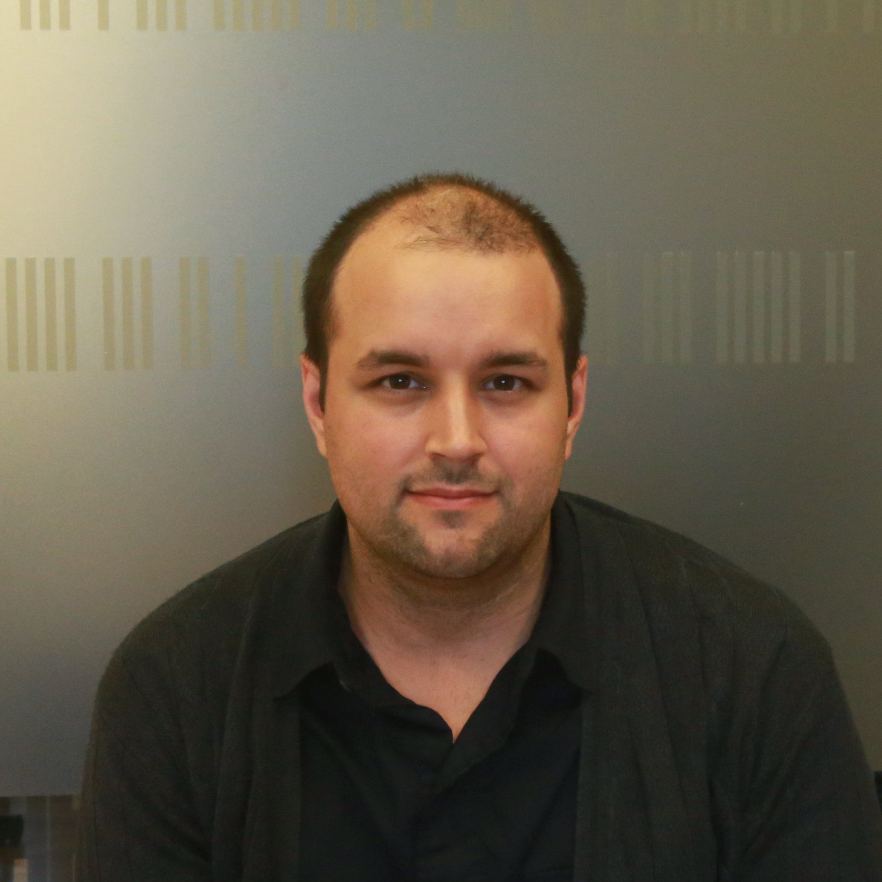
INSTRUCTOR
Name: J. Alstan Jakubiec
Email: alstan.jakubiec@daniels.utoronto.ca
Office: DA321; Daniels Faculty; 1 Spadina Cres.
Office hours: Thursdays 11am – 1pm
or by appointment
Course meeting times:
Meeting time: Tuesdays 10am – 1pm

Our first meeting is on Tuesday, September 12, 2023.
II COURSE OVERVIEW

COURSE DESCRIPTION
Sustainability is a priority for universities worldwide, including the University of Toronto. Many universities are developing operational sustainability goals in addition to placing emphasis on educating students about sustainability. For some concrete examples at U of T, see the 2020 Annual Report of the President’s Advisory Committee on the Environment, Climate Change, and Sustainability (CECCS) of which this course falls under the ‘Campus as a Living Lab’ section. By bridging sustainability goals, sustainable research and education about sustainability, modern university campuses and operational contexts can be increasingly labeled living laboratories of sustainable practice. Such living lab approaches offer a potential for universities—and their students—to play a role in the transition to sustainable higher education.

ENV1103 will apply the living lab concept to operational sustainability concerns at the University of Toronto. We will begin by looking at the literature on university sustainability and the living laboratory concept. Most of the course will engage students in an applied research project on an aspect of campus sustainability while working in close cooperation with U of T staff. Students will develop the skills needed to present information relative to these real-world problems and develop proposed solutions integrating their own fields of study with new topics and practical, quotidian university concerns.

Confidentiality
You will be working on real issues for U of T staff. Although the information you are likely to research and analyze is not secret, it may certainly be sensitive in nature, and you may be given access to internal or proprietary information. You are to maintain confidentiality in all the work that you do on behalf of your client. Outside of class, you may comment generically that you are working on a project for a given organization. However, you should not discuss, tweet, Facebook, reference in LinkedIn or otherwise publicize the content of your work before checking with your client on his/her preferences on the subject and receive that acknowledgement in writing via email. Breaching the confidence of the client will result in an academic sanction.

Posting Final Reports Online
To provide future students with useful raw material for their projects in this course, and to allow knowledge to be built up cumulatively over time through this course, we plan to post all final reports on a U of T website. The final report as submitted for marking, complete with the names of all students in that group, but not containing any comments or grades from instructors, would be posted. If you have any concerns about this (e.g. would prefer your name not to be included), please contact Alstan.

STUDENT LEARNING OUTCOMES
A key purpose of this course is to expose students to real‐world constraints and opportunities involved in trying to implement a sustainability agenda in the specific institutional context of U of T. Sustainability solutions that are desirable in principle may be difficult to implement in practice given institutional mandates, capabilities and cultures. A key outcome of the course will be a better understanding of how to pursue sustainability goals in real world contexts.

The specific learning objectives of the course are:
- Learn to identify and articulate a sustainability problem of practical import to the university
- Learn to develop and articulate a realistic workplan to address that problem
- Learn to work effectively with other members of a group to fulfil that workplan
- Learn to work effectively with a client from a non-academic portion of the university
- Contribute in a concrete way to the university’s actions to improve sustainability
- Learn about the role of the university in achieving operational sustainability, and the practical institutional constraints on sustainability action
- Develop an understanding of the campus as living lab approach to university sustainability, its potential and limitations
- Develop substantive knowledge in one area of operational sustainability at the university

III HOW THE COURSE IS ORGANIZED

This course will engage students with operational sustainability projects identified by U of T staff working in various offices at the University of Toronto. Students will be organized into groups, each of which will be assigned a single project overseen by one or more U of T staff members (clients). Most of the course will consist of weekly meetings with the staff clients and instructors in order to undertake the group project. We will also have project-driven topical content on descriptive statistics and data presentation, delivered over two class periods. Groups will produce a mid‐term and final report and give a mid‐term and final presentation. Each student will also submit two peer-reviews of their group members and group working dynamics.

Students in the course will complete 3 assignments as well as a final presentation and report. The first assignment is to craft a problem statement in conjunction with a client to describe the sustainability issue at hand and an initial approach to problem solving. The second assignment is to produce an annotated bibliography of related literature. The third assignment is to produce a draft presentation and report outline of work towards the sustainability problem posed by your client. During week 12 and extending into the final assessment period, the final presentation and report will be submitted. Clients will provide feedback to student groups, but they will not be engaged in the assignment of marks.

Class will have occasional lectures or other activities (for example, the data presentation content), but class time will primarily consist of group discussion including regular meetings with clients, and discussion with the course instructor. Each group will meet during class time. The instructor will be available at those times, group’s will discuss with them each week regarding progress on their project. Each group will also be expected to meet periodically with their client. These meetings will occur during class, via digital meeting software, or outside class at a time and place to be arranged with the client.

A critical aspect of this course is the ability of students to work collaboratively together in a group environment and to work effectively with a university staff person acting as a client for their work. Peer reviews will be used twice during the course. The first peer review will serve to provide information on how well each group is working together. Students are encouraged to discuss and resolve group process issues in their weekly group meetings and during their regular meetings with the instructor. The second review will occur at the end of the term. The results of the second review will be used, as appropriate, to adjust individual marks from the group averages; therefore, it is best to resolve any group issues ahead of time.

COURSE SCHEDULE & RELEVANT SESSIONAL DATES:
Date | Class Activities | Assignment
(Week 1)  12 Sept. | - Introduction of class members, faculty, course overview  - (11:00 – 12:00) Client presentations and Q&A  - Group creation / distribution of preferred topics in class | A1 – Problem statement assigned.
(Week 2)  19 Sept. | - Meet and discuss problem statement ideas with clients  - Lecture and discussion: Campus as a living laboratory, Definition of sustainability, sustainable development goals
(Week 3)  26 Sept. | - In-class discussions of draft problem statement with instructor and clients  - Meet with groups to further develop problem statement
(Week 4)  3 Oct. | - Present near-final problem statement draft to clients  - Meet with groups to refine and complete problem statement  - Lecture and brief discussion: What is a literature review? | A1 – Problem statement due.**  A2 – Literature review assigned.
(Week 5)  10 Oct. | - In-class discussions of literature selection with instructor and clients  - Meet with groups to work on literature review
(Week 6) *  17 Oct. | - Meet in groups during class time  - Workshop and discussion: Presenting data, interpreting data  [No client meeting this week.] | (Submit before class: example of data presentation from one of your literature review sources.)
* Indicates weeks where client meetings are not planned
** Assignments are due on Friday at 11:59pm of the week indicated. You may bring draft versions to class for early feedback.
Date | Class Activities | Assignment
(Week 7) *  24 Oct. | - Workshop pt. 2: Descriptive statistics and presentation of data  [No client meeting this week.] | A2 – Literature review due.**  A3 – Midterm action plan / draft assigned.  Complete first group peer-review exercise.
(Week 8)  31 Oct. | - Meet with clients and refine study methodology / discuss action plan
7 Nov. | Reading week – No class!
(Week 9)  14 Nov. | - Midterm action plan presentation w/ clients present. | A3 – Midterm action plan / draft due, including in-class presentation.**
(Week 10) *  21 Nov. | - Groupwork during class time and meeting with instructor.  - Intra-group peer-review exercise.  [No client meeting this week.]
(Week 11)  28 Nov. | - Meet with clients and instructor during class time.  - Groupwork during class time.
(Week 12)  5 Dec. | - Final progress presentations with clients present. | Final presentation to be delivered during class time pending client availability.
(Final assessment period) |  | Final reports due by 15 December.  Complete second group peer-review exercise.
* Indicates weeks where client meetings are not planned
** Assignments are due on Friday at 11:59pm of the week indicated. You may bring draft versions to class for early feedback.

IV EVALUATION/GRADING SCHEME

Due Dates
All written assignments should be submitted via Quercus as a PDF. No hard copies are required, and assignments will be returned by email or through Quercus. As noted in the course schedule, assignments are typically due on Friday at 11:59pm of the week noted unless otherwise specified.

MARK BREAKDOWN
Assignment Due Date Percent Marks
A1. Problem statement | 6 Oct. | 15%
A2. Literature review | 27 Oct. | 15%
Initial peer review | 27 Oct. | 5%
A3.a. Mid‐term presentation | 14 Nov. | 10%
A3.b. Mid‐term report | 17 Nov. | 10%
Final presentation | 5 Dec.* | 10%
Final peer review | 15 Dec. | 5%
Final project paper | 15 Dec. | 30%

* The actual date of final presentations may depend on client availability.

Note: if an unexpected technical issue occurs with a university system (e.g., Quercus services, network outage) that affects availability or functionality, it may be necessary to revise the timing or weighting of the assessments.

CRITERIA FOR EVALUATING WORK
The primary criteria used in evaluating written work are the following:
- Mechanics: Your work must be completely free of grammatical errors, spelling errors or major factual errors. References should be in APA format.
- Style: Your work should be written in a clear and unambiguous style and with legible figures which assist, rather than impede, communication with the reader.
- Structure: Your written work should have a precise focus responding to the campus sustainability issue being addressed and a structure which logically flows from that focus.
- Accuracy: Your work should avoid ambiguity and vague generalities and focus on providing clear and direct information and logical recommendations. The work should not have major factual errors or inaccuracies.
- Analysis: Your work should display understanding of the topic and key issues surrounding it. Your conclusions should be based on a depth of research and understanding of the campus sustainability issue you are working on.

The primary criteria used in evaluating oral presentations are the following:
- Success in communicating key concepts succinctly and accurately, thereby demonstrating sound understanding of the work being presented.
- Mechanics of communication, such as manner of speaking (including good diction and tone), structure of the presentation and level of organization.
- Ability to respond appropriately and fairly to questions and contribute to and stimulate unstructured discussion among peers.

A note on professionalism
Whether in draft or final form, work plans, interim reports and presentations that are distributed to the professor and client are expected to be of professional quality. This includes an expectation of superior intellectual ideas, writing, formatting and presentation of products. Remember that an important aspect of successful interactions includes the way in which you prepare, rehearse your material, look and sound when you communicate with clients and staff in their organizations. Please note that client satisfaction throughout the term will inform their interactions with you.

V COURSE POLICIES

- This statement from the university is of utmost importance: “The University of Toronto is committed to equity, human rights and respect for diversity. All members of the learning environment in this course should strive to create an atmosphere of mutual respect where all members of our community can express themselves, engage with each other, and respect one another’s differences. U of T does not condone discrimination or harassment against any persons or communities.”
- I will respond to e-mail inquiries within 24 hours on weekdays. I appreciate it if you prepend a tag [ENV1103] to the e-mail subject line when writing me about the course. Contact through Quercus is also fine but less preferable.
- This course is predominantly in-person; however, clients may wish to meet with their groups digitally.
- All assignments are due at the specified time and date. Late submission will result in a 10% deduction (of each assignment’s total grade) per day unless an extension has been granted.
- Students who for reasons beyond their control are unable to submit an assignment by its deadline must obtain approval from their instructor for an extension within the term, and this extension must suit all of their group members.
- All assignment submissions will take place through Quercus.

VI TECHNOLOGY REQUIREMENTS

Specific guidance from the U of T Vice-Provost, Students regarding student technology requirements is available here: https://www.viceprovoststudents.utoronto.ca/covid-19/tech-requirements-online-learning/

Advice for students more broadly regarding online learning is available here: https://onlinelearning.utoronto.ca/getting-ready-for-online/

This course requires the use of computers, and of course sometimes things can go wrong when using them. You are responsible for ensuring that you maintain regular backup copies of your files, use antivirus software (if using your own computer), and schedule enough time when completing an assignment to allow for delays due to technical difficulties. Computer viruses, crashed hard drives, broken printers, lost or corrupted files, incompatible file formats, and similar mishaps are common issues when using technology, and are not acceptable grounds for a deadline extension.

VII INSTITUTIONAL POLICIES AND SUPPORT

ACADEMIC INTEGRITY
Academic integrity is essential to the pursuit of learning and scholarship in a university, and to ensuring that a degree from the University of Toronto is a strong signal of each student’s individual academic achievement. As a result, the University treats cases of cheating and plagiarism very seriously. The University of Toronto’s Code of Behaviour on Academic Matters (https://governingcouncil.utoronto.ca/secretariat/policies/code-behaviour-academic-matters-july-1-2019) outlines the behaviours that constitute academic dishonesty and the processes for addressing academic offences. Potential offences include, but are not limited to:
In papers and assignments:
- Using someone else’s ideas or words without appropriate acknowledgement.
- Submitting your own work in more than one course without the permission of the instructor.
- Making up sources or facts.
- Obtaining or providing unauthorized assistance on any assignment.
On tests and exams:
- Using or possessing unauthorized aids.
- Looking at someone else’s answers during an exam or test.
- Misrepresenting your identity.
In academic work:
- Falsifying institutional documents or grades.
- Falsifying or altering any documentation required by the University.
All suspected cases of academic dishonesty will be investigated following procedures outlined in the Code of Behaviour on Academic Matters. If you have questions or concerns about what constitutes appropriate academic behaviour or appropriate research and citation methods, you are expected to seek out additional information on academic integrity from your instructor or from other institutional resources (see https://www.academicintegrity.utoronto.ca/).
COPYRIGHT
If a student wishes to copy or reproduce lecture presentations, course notes or other similar materials provided by instructors, he or she must obtain the instructor's written consent beforehand. Otherwise all such reproduction is an infringement of copyright and is absolutely prohibited. More information regarding this is available here: https://teaching.utoronto.ca/ed-tech/audio-video/copyright-considerations/

ACCESSIBILITY NEEDS
Students with diverse learning styles and needs are welcome in this course. The University of Toronto is committed to accessibility: if you require accommodations for a disability, or have any other accessibility concerns about the course, please contact Accessibility Services as soon as possible.

ADDITIONAL SERVICES and SUPPORT
The following are some important links to help you with academic and/or technical service and support

- General student services and resources at Student Life
- Full library service through University of Toronto Libraries
- Resources on conducting online research through University Libraries Research
- Resources on academic support from the Academic Success Centre
- Learner support at the Writing Centre
- Information for Technical Support/Quercus Support

